MyEnds Community Fund
Inspiring Young Enfield Hyper-Local Partnership

Funding Brief

The MyEnds Community Fund will support individuals and grassroots community and voluntary organisations to access grants of up to £5,000 to deliver hyper-local projects within or near the Ponders End and Craig Park Youth and Family Hubs. These areas have been identified as needing targeted support to help tackle serious youth violence and improve local outcomes for young people and their families.

MyEnds empowers communities by providing the tools and resources needed to lead their own prevention initiatives. This includes creating support networks for parents and carers, offering after-school programs, delivering neighbourhood-based youth work in youth and family hubs, and facilitating a range of activities such as sports, music, arts, and drama.

This funding opportunity is part of the Inspiring Young Enfield (IYE) – Hyper-Local Initiatives programme, a partnership led by the Youth Development Service (YDS), which will also provide practical support, mentoring, and guidance to successful applicants throughout the lifecycle of their project.

Our Vision

We want to build safer, stronger communities where young people can thrive. This fund is designed to support grassroots projects that:

- Reduce or prevent youth violence
- Build resilience in young people, families, and local communities
- Offer positive, inclusive activities for those most at risk
- Respond to the needs identified by local people
- Strengthen community capacity and encourage long-term collaboration

Who Should Apply

We are inviting applications from:

- Individuals and small community or voluntary organisations with a track record of delivering activities in Ponders End or Craig Park
- Unregistered or emerging groups that have strong community roots that could partner up with constituted organsiations
- Organisations that are willing to receive capacity-building support and work in partnership with the Youth Development Service

Applicants must be able to deliver within Haselbury, Upper Edmonton, Lower Edmonton, Edmonton Green and Ponders end wards or in proximity of our Youth and Family Hubs (Craig Park and Ponders End Youth and Family Hub)

These areas have been identified as priorities for targeted support due to the prevalence of serious youth violence and the need to improve outcomes for young people and their families. They are characterised by high levels of deprivation, which often contribute to the complex challenges faced by residents. Addressing these issues requires a holistic, place-based approach that draws on the strengths of existing services and community networks.

In particular, these areas have strong connections to our Youth and Family Hubs, which play a key role in providing early intervention, tailored support, and access to vital resources. By aligning targeted interventions with the work of the hubs, we aim to create safer environments, enhance opportunities for young people, and foster greater resilience within families and the wider community.

What You Can Apply For

- Activities that promote positive engagement among young people (e.g. arts, sports, mentoring, peer learning, life skills, etc.)
- Initiatives that improve emotional well-being, reduce harm, or address trauma
- Projects that build community cohesion and challenge antisocial behaviour or local conflict
- Youth-led campaigns or projects that give young people a voice and offer leadership opportunities

You can apply for up to £5,000. All projects must be delivered between September 2025 and March 2026.

What Support is Available

Successful applicants will be supported by the Youth Development Service, who will:

- Offer mentoring, advice, and help with delivery planning
- Provide access to resources, networks, and relevant training
- Assist with safeguarding, monitoring, and evaluation
- Help emerging groups with governance, policies, and reporting
We are especially keen to support hyper-local initiatives that are rooted in the community, led by people with lived experience, and based on trusted relationships between young people and adults.
Hyper-local means tailored to the specific needs of your street, estate, neighbourhood, or community — delivered by people who live and work locally and understand the area deeply.
If you need a host organisation to support your bid or help with documentation, we can help connect you to suitable local partners.

What You’ll Need to Have in Place

- A clear project plan and budget
- A safeguarding policy (or commitment to develop one with support)
- Evidence of local need and community engagement
- Commitment to equal opportunities, inclusion, and respectful practice
- Public liability insurance (or access to it through a host organisation)

Key Dates
To support potential applicants, we will be hosting two online information sessions via Microsoft Teams on the following dates:

- Tuesday 10th June, 4:00pm – 5:00pm
- Thursday 12th June, 4:00pm – 5:00pm

These sessions will provide an overview of the grant process, guidance on completing the application, and an opportunity to ask questions.
The deadline to submit your application is Sunday 6th July.
To attend one of the online sessions or to find out more information about the fund, please email iyemyends@enfield.gov.uk to receive the Microsoft Teams link or further details.

Please submit the completed application form before 12 midnight Sunday 6th July to iyemyends@enfield.gov.uk

INSPIRING YOUNG ENFIELD MYENDS COMMUNITY FUNDING APPLICATION FORM

CONTROL SHEET(YLFC.1)

Date:

Section 1: Project Details

Q1. Project title, duration and costs
Project start date |  | End date
Funding requested |  | Total project cost

Q2. Contact details of applicant and status (Organisation name, address, email and contact no.)
Q3 Organisation type

Community/voluntary group

Individual applicant

Charity group CIC

Non-profit organisation

Other – Please specify:

Q4 When did your organisation start?

DD/MM/YYYY

Q5 What is your annual income?
Under £10,000

10,000 – 50,000

50,000 – 250,000

Q6 Funding request summary: This should be a summary of your proposed activity.
This is your chance to briefly explain your project idea and how the funding will be used. You should summarise:
- What you plan to do
- Who it’s for
- Why it’s needed
- What difference it will make (outcomes)
- How the funding will help you deliver it
Keep it clear and to the point – this section should give us a strong overview of your

Max 500 words.

Q7 How would your project contribute to the MyEnds aims and what changes do you hope to see in the participants on your programme ?

Reducing youth violence
Engaging vulnerable young people in positive activities
Holistic support for families
Increasing access to local services i.e. Ponders end family hub, Craig Park youth and Family Hub
Building community resilience

Please tick as many as apply to your project and describe how your project will tackle them.

Max 300 words.

Q8 Who are the young people or families your work will be targeted at, and what do you understand their needs to be? This question is asking you to describe who your project is for – for example, young people at risk of exclusion, families facing financial hardship, or young people with special educational needs.

It also asks what you understand their challenges or needs to be, such as low confidence, lack of access to safe spaces, or needing support with behaviour, mental health, or employment.

This helps us understand how well your project is focused on those who need it most.

Max 300 words.

Q9 How many young people/families will receive support through your programme? This means the total number of individuals your project will directly support. Please give an estimate of how many young people and/or families will take part in or benefit from your programme. This helps us understand the reach and scale of your project.

Try to be as realistic as possible

Max 300 words.

Q10 What outcomes will your programme achieve? Outcomes are the positive changes or differences your programme will make for the young people, families, or community you support. This could include improvements in behaviour, skills, confidence, wellbeing, or relationships. Think about what will be different as a result of your programme, not just what activities you will run.

Q11 Please confirm what policies you have in place i.e. safeguarding, health and safety and insurance policies etc. We need to know what formal policies or procedures your organisation has to help keep young people, staff, and volunteers safe. This includes documents such as your Safeguarding Policy, Health and Safety Policy, and details of your insurance cover. These policies show that your organisation is running responsibly and meeting legal or safeguarding requirements.

Q12 Can you confirm that your project will be delivered within Haselbury, Upper Edmonton, Lower Edmonton, Edmonton Green and Ponders end wards or in proximity of our Youth and Family Hubs (Craig Park and Ponders End Youth and Family Hub).
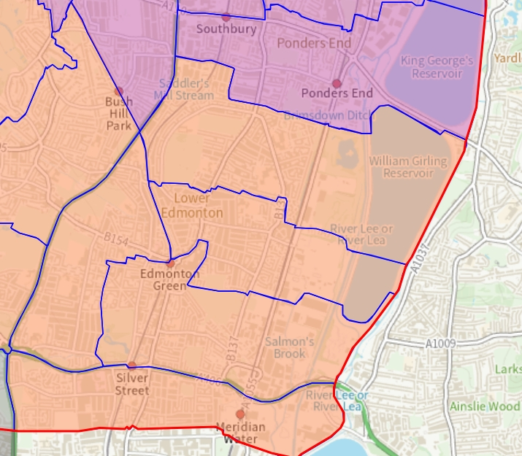

Can you provide details below of the location of your activity.

Yes

No

If answered yes, please detail location:

BUDGET DETAILS FOR THE PROJECT September 2025 – March 2026

 | Please indicate total project expenditure and funding on the table below - This refers to the full cost of delivering your project, including all the things you need to pay for (such as staff, equipment, venue hire, travel, etc.). Please use the table to show how much your project will cost in total – including the amount you are requesting from us and any other sources of funding.
 |  | Expenditure 2025 |  |  |  |  | Expenditure 2026
Budget information |  |  |  | Q3 Sept | Q4 Oct - Dec | TOTAL | Q1 Jan - Mar |  |  |  | Total

Appendix 2. DETAILED TARGET SETTING AND EVALUATION FOR PROJECTS (Outcomes & Outputs)
Please list concise details of your anticipated outputs to be delivered, and the timeframe for this.

T DETAILED TARGET SETTING AND EVALUATION FOR PROJECTS (Outcomes & Outputs)
Please list concise details of your anticipated outputs to be delivered, and the timeframe for this.

Outputs are the specific activities, services, or products your project will deliver. These are things you can count or measure – for example, the number of sessions you run, how many young people take part, how many workshops are delivered, or how many resources are created.

Think of outputs as the tangible things your project will do or provide.
 |  | Outputs 2025 |  |  |  |  | Outputs 2026
Outputs |  |  |  | Q3 Sept | Q4 Oct - Dec | TOTAL | Q1 Jan - Mar |  |  |  | Total

Match Funding (where applicable)
=
☐

Q13 Will this funding be part of a wider programme or combined with other funding?

Yes

No

If answered yes, please detail why.

Please submit the completed application form before 12 midnight Sunday 6th July to iyemyends@enfield.gov.uk

